**Master-slave connection through SSH method :**

**1.Take package name from user if not available then install package..**

**Credential created**

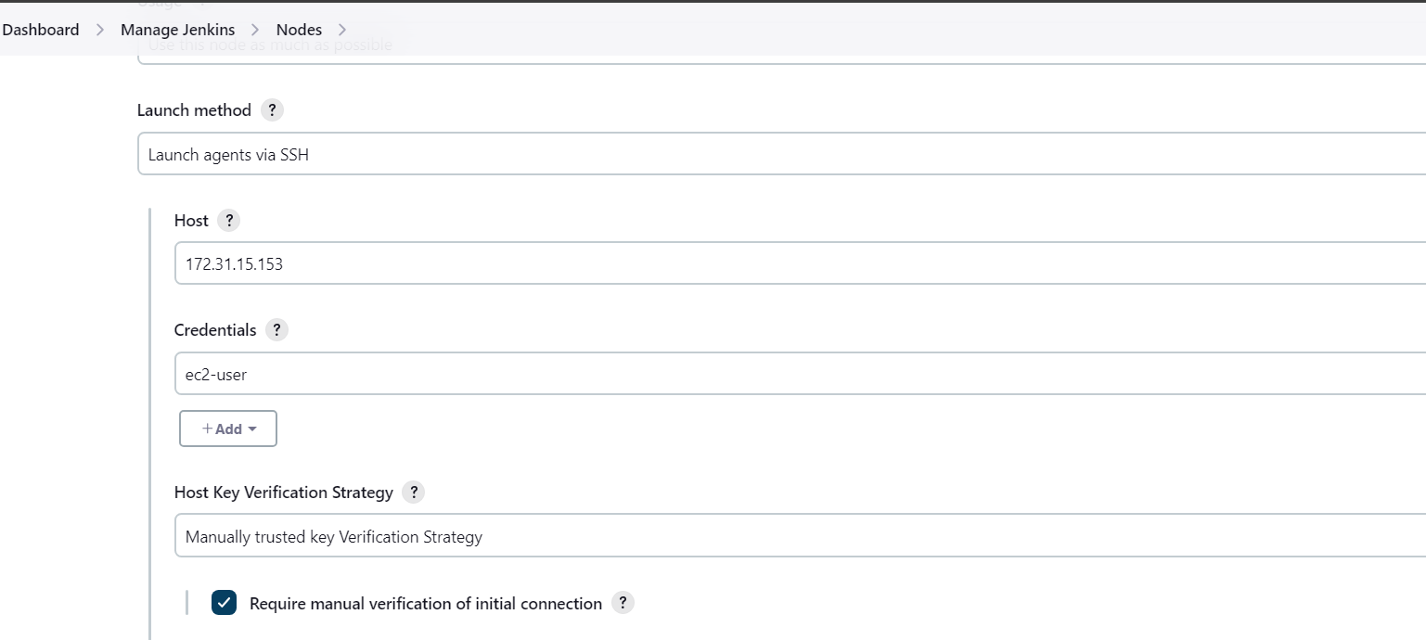

**Slave created and connected**

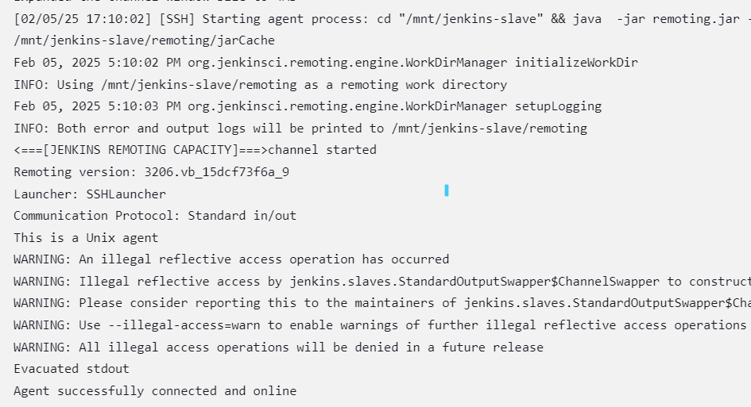

**Job created to check package is available or not using Boolean parameter**

